MINI PROJECT DOCUMENTATION
Problem Statement
Healthcare Data Analytics – Senior Data Analyst Case Study
Business Problem
A multi-specialty healthcare organization wants to understand patient admissions, hospital operations, billing, payment collection, and patient experience. The current operational dataset is raw and contains duplicates, missing values, inconsistent text/casing, inconsistent date formats, numeric values stored as text, and other data-quality issues.
Objective
Clean, validate, transform, and analyze the raw healthcare data to create reliable KPIs and actionable insights for hospital management.
Key Business Questions
- What are the monthly admission trends?
- Which departments have the highest patient volume?
- What are the average length of stay and average waiting time by department?
- Which diagnoses contribute most to admissions and billing?
- What is the total billed amount, amount collected, outstanding amount, and collection rate?
- How does insurance provider performance compare?
- What factors are associated with lower patient satisfaction?
- What percentage of records contain missing or invalid data?
- Identify duplicate patient/admission records and define a deduplication rule.
- Build a management dashboard showing admissions, revenue, collections, outstanding amount, average stay, waiting time, and satisfaction.
Data Cleaning Requirements
- Standardize Patient ID and text fields.
- Standardize Gender, Department, Diagnosis, Insurance, Ward, Payment Mode, and Admission Status.
- Convert all dates to a single date format.
- Convert Bill Amount and Amount Paid into numeric values.
- Handle null/missing values using documented business rules.
- Detect and remove/flag duplicate records.
- Validate discharge date >= admission date.
- Validate Length_of_Stay against admission/discharge dates.
- Check for unreasonable values in wait time, satisfaction, BP, glucose, and financial fields.
- Create calculated fields such as Outstanding Amount, Collection Rate, Month, Age at Admission, and Data Quality Flag.
Expected Deliverables
- Cleaned dataset.
- Data-quality summary.
- SQL/Python/Excel transformation logic.
- KPI summary.
- Power BI dashboard or Excel dashboard.
- Business insights and recommendations based on the cleaned data.

Standardize Patient ID and text fields.
Patient_ID column
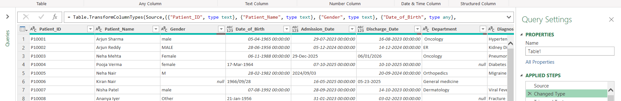

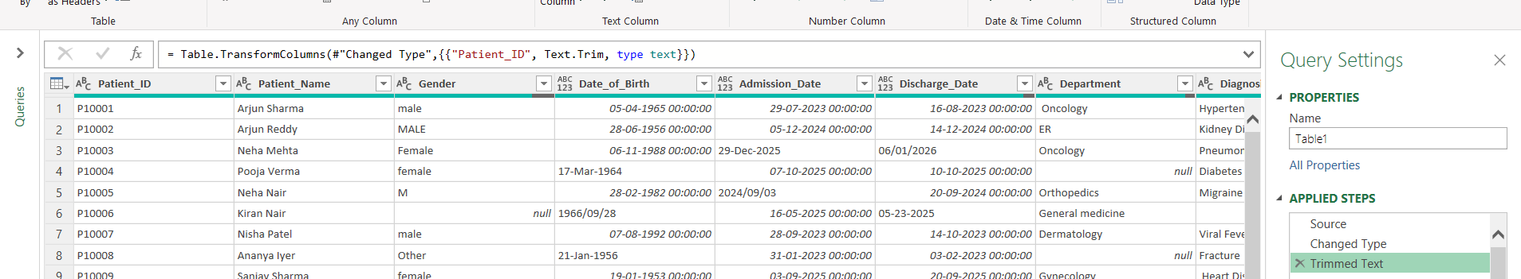

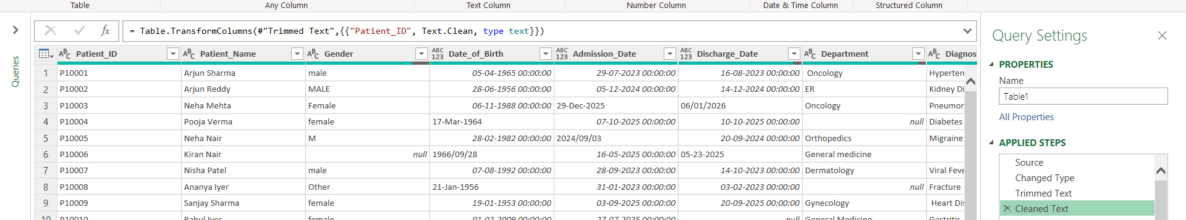

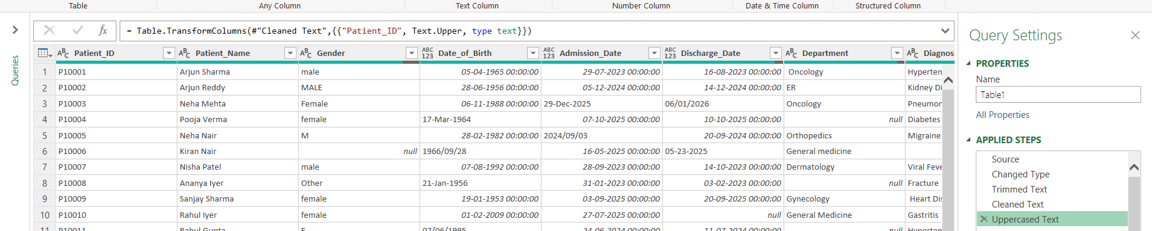

Standardize Gender, Department, Diagnosis, Insurance, Ward, Payment Mode, and Admission Status.
GENDER Column
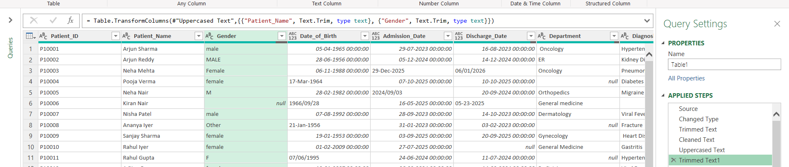

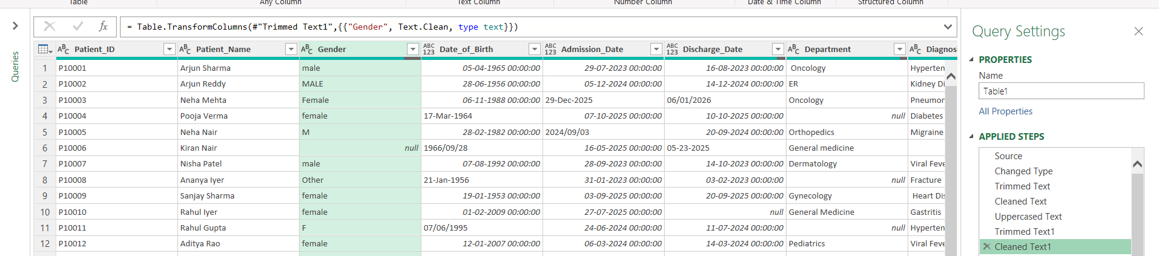

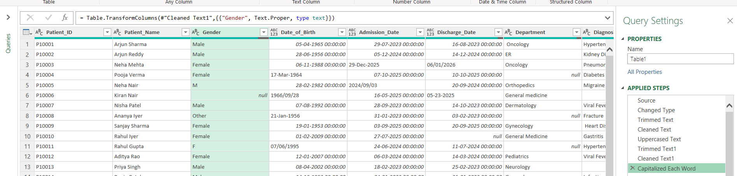
For Department column
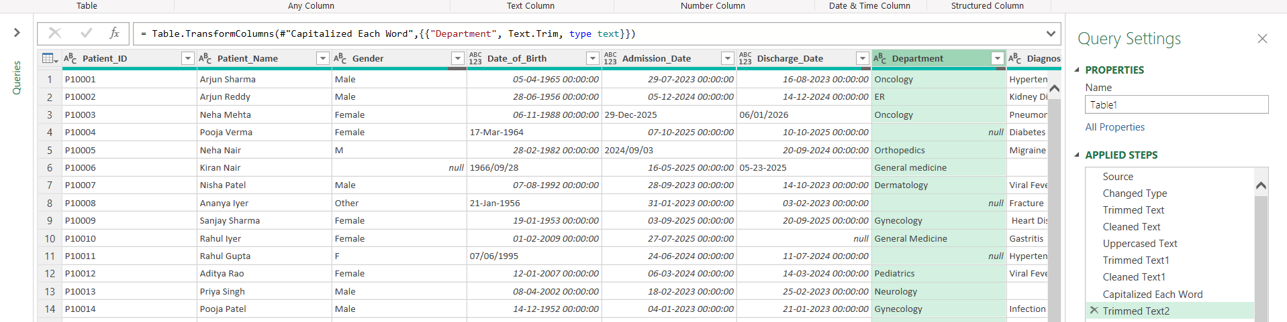

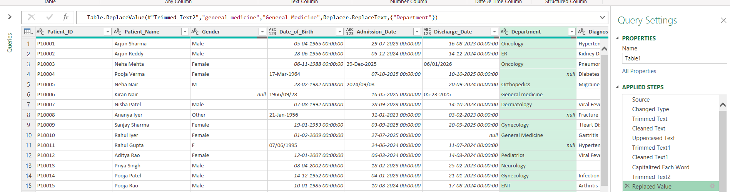

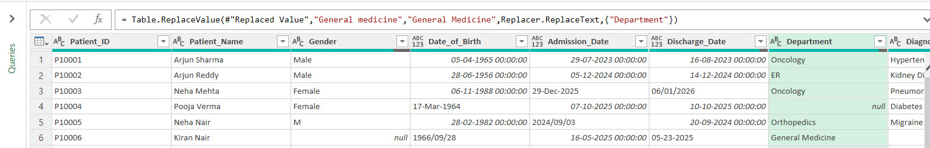

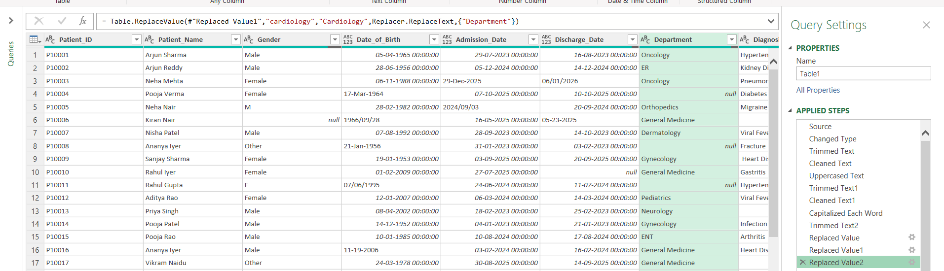

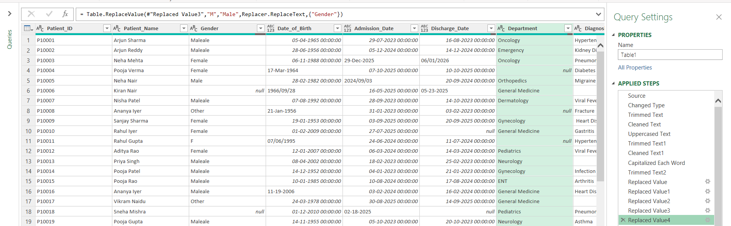

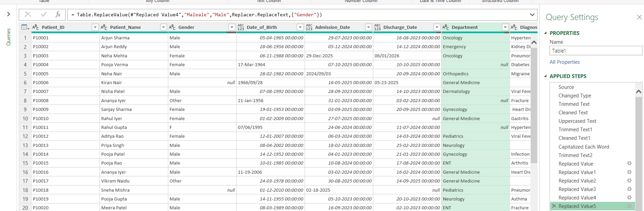

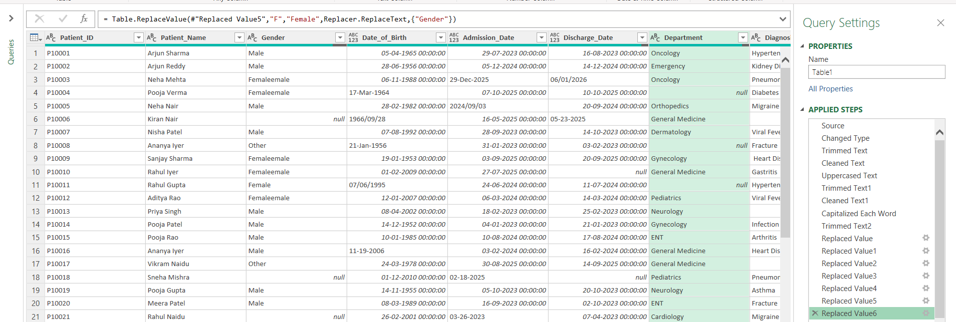

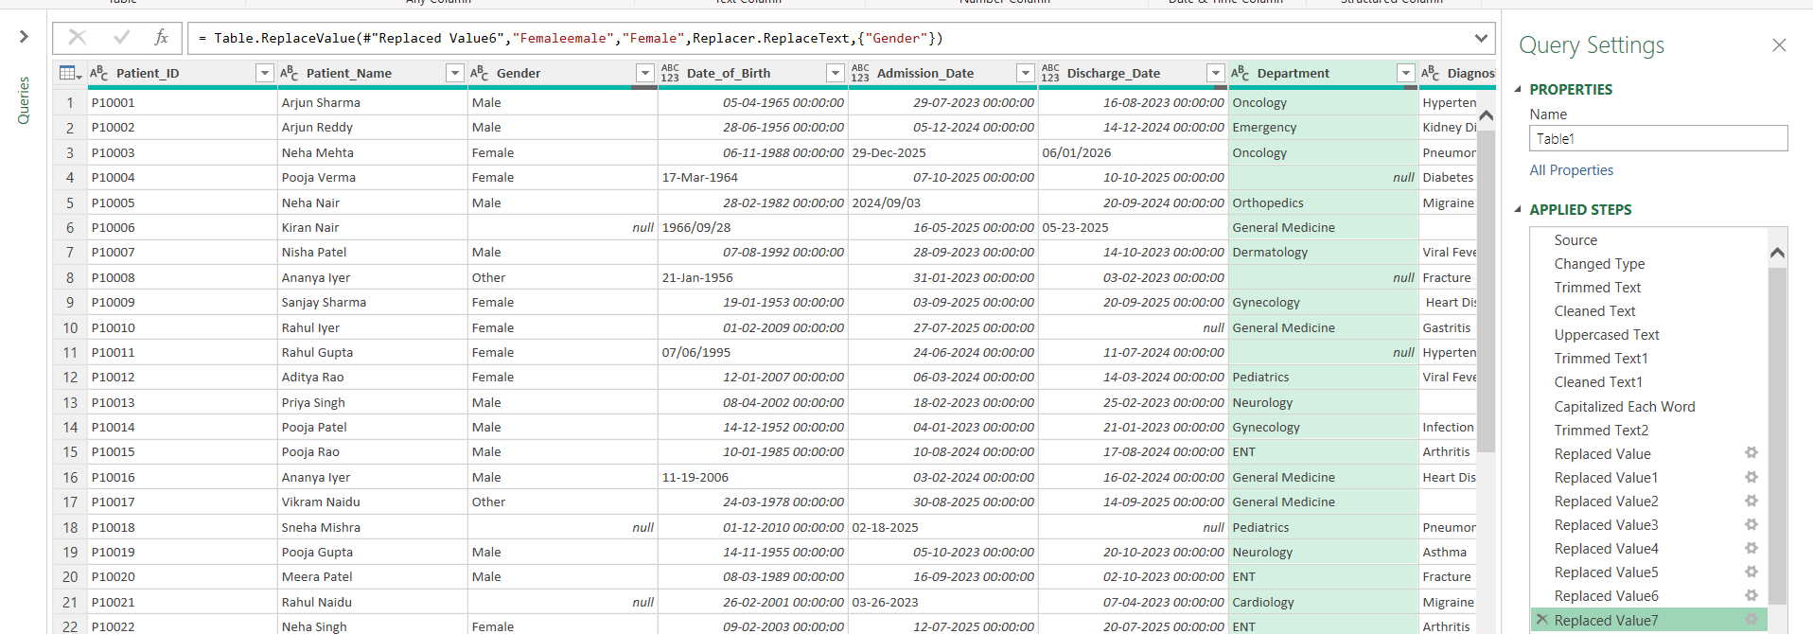

For Diagnosis Column

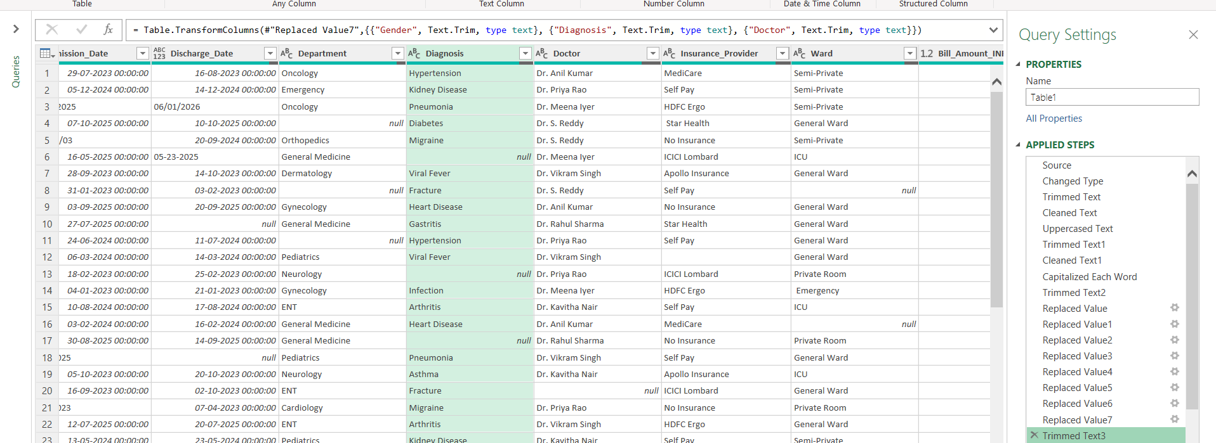

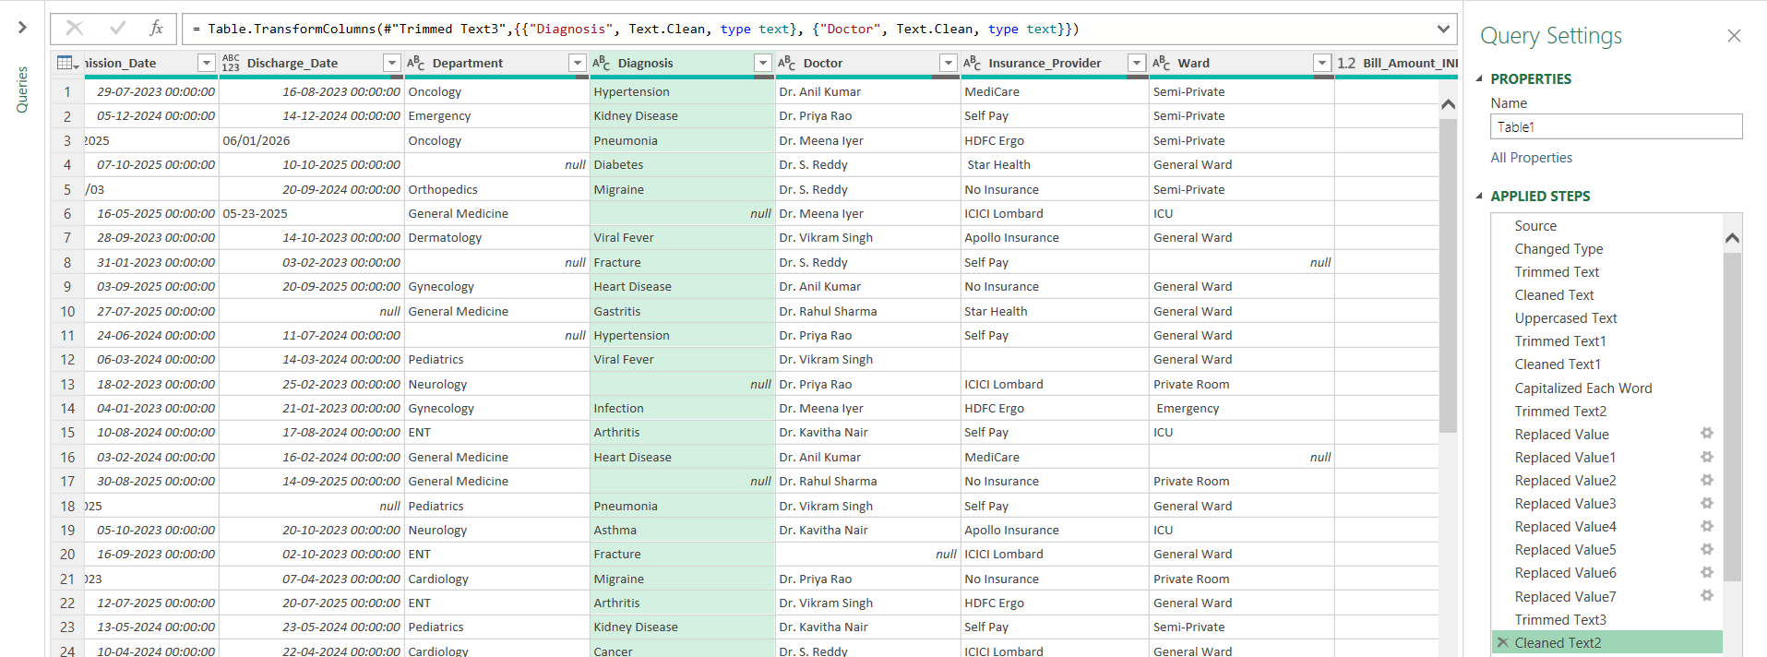

For Insurance Provider column

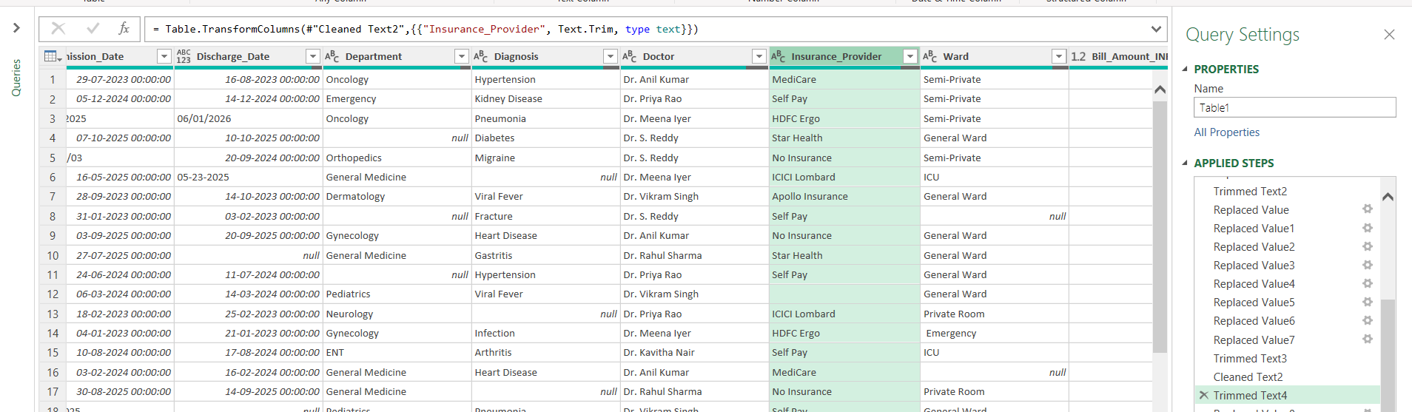

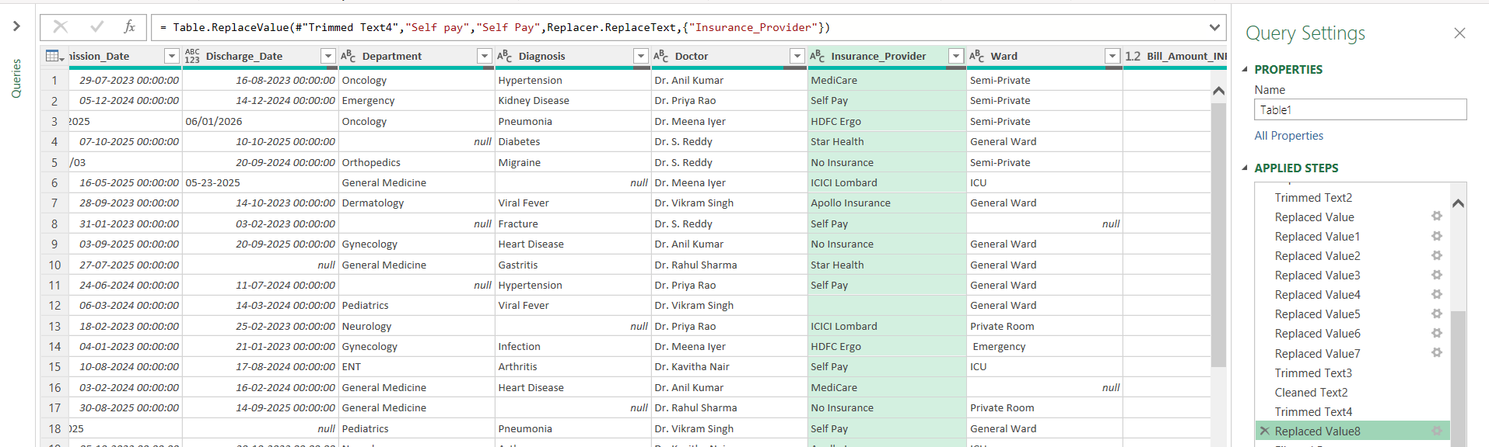

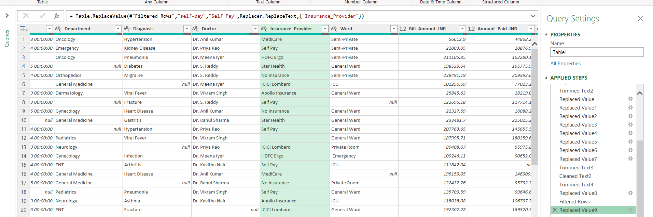

For Ward Column

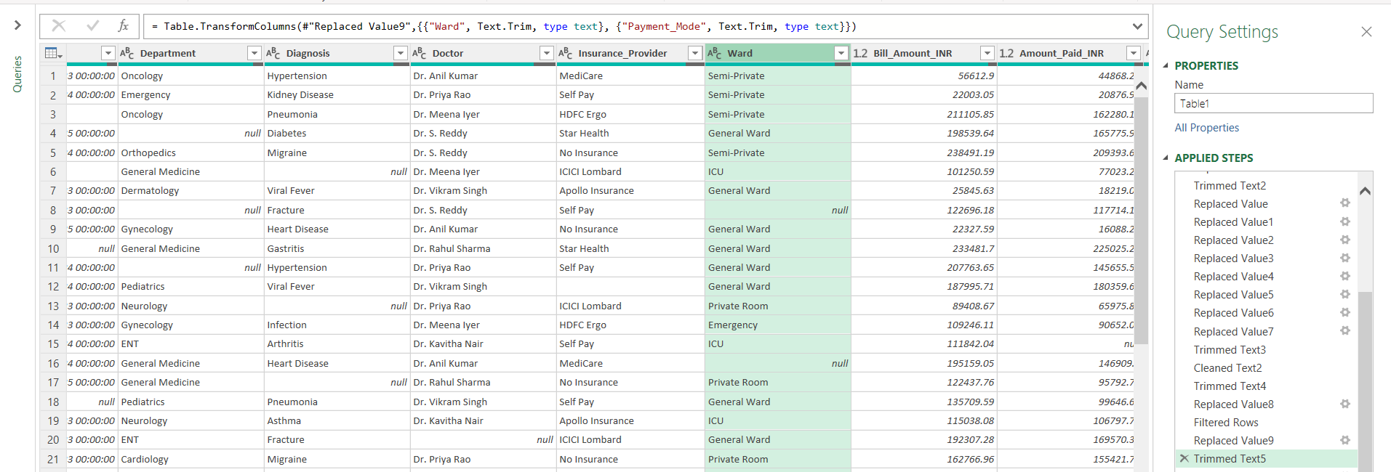

For upi to UPI

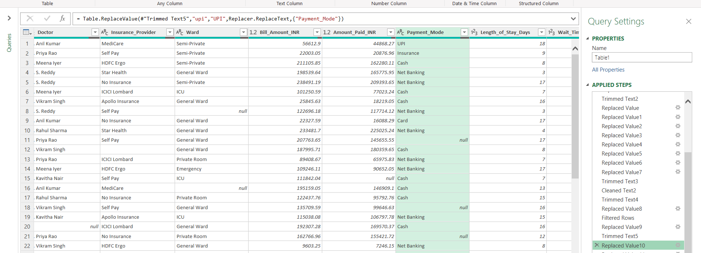

For cash replace with Cash

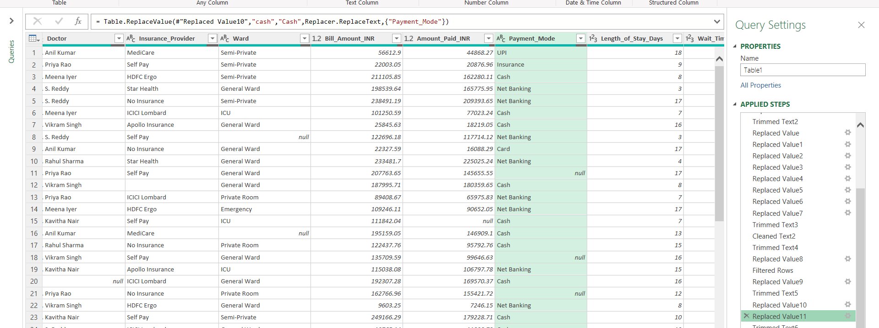

For Admission status column

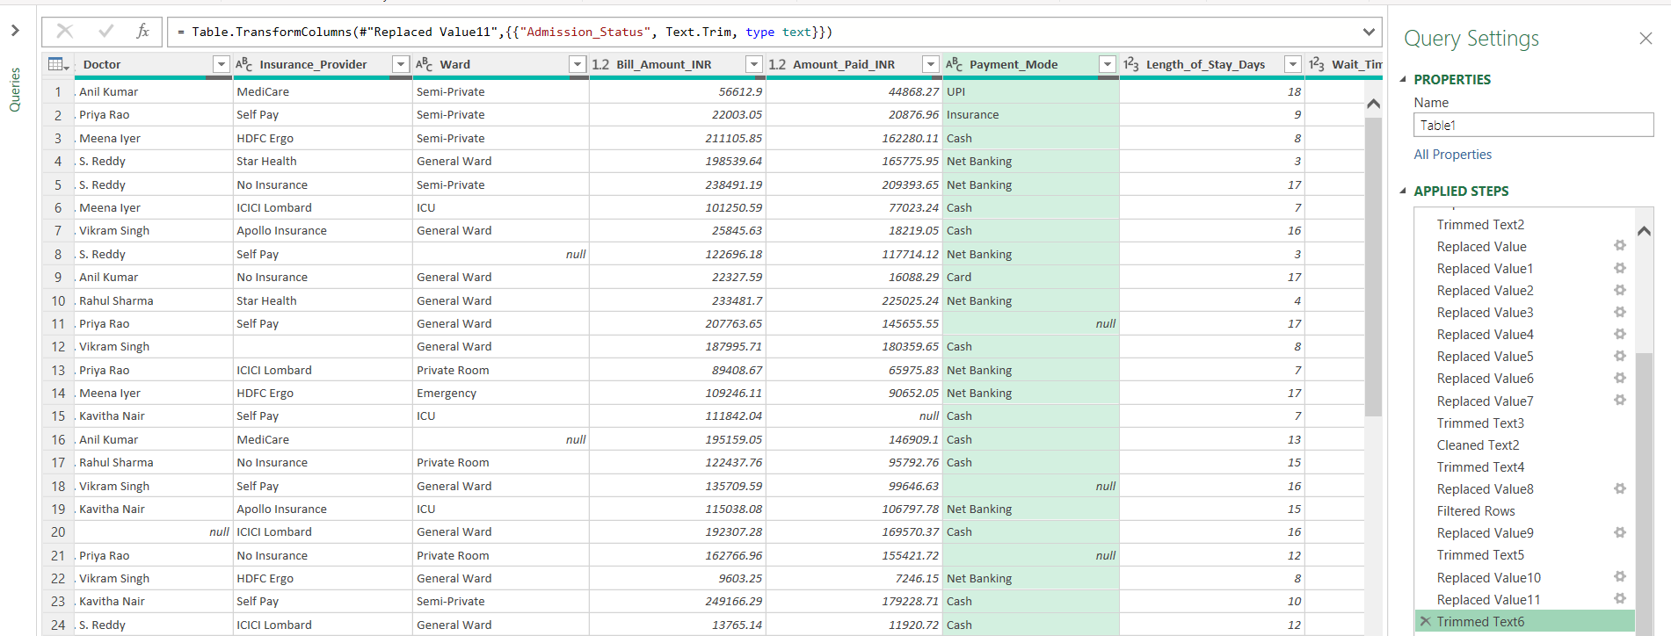

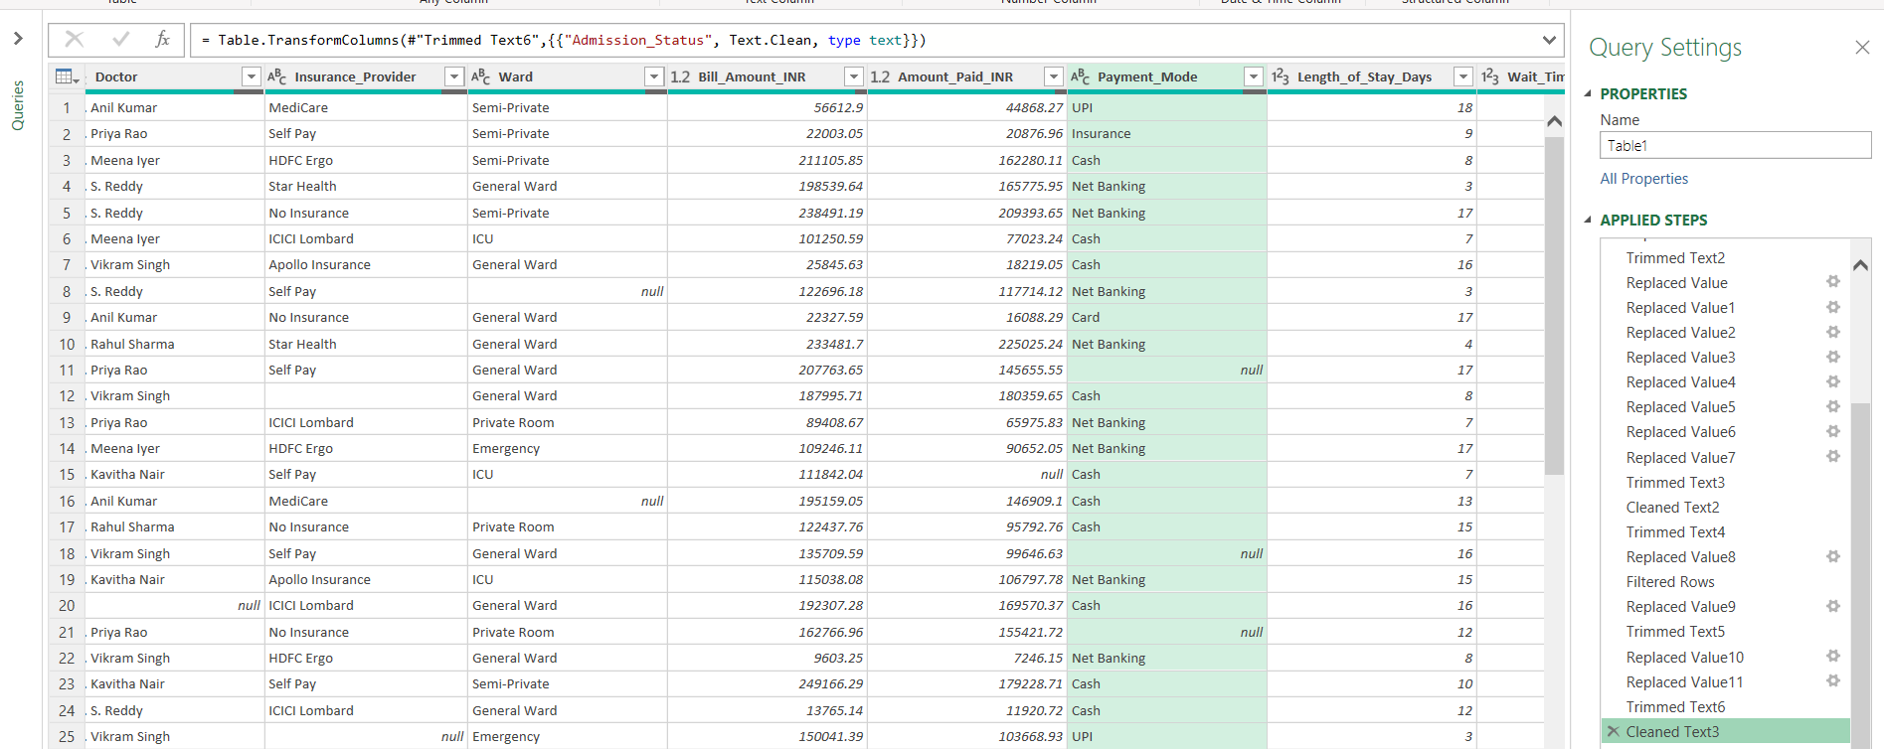

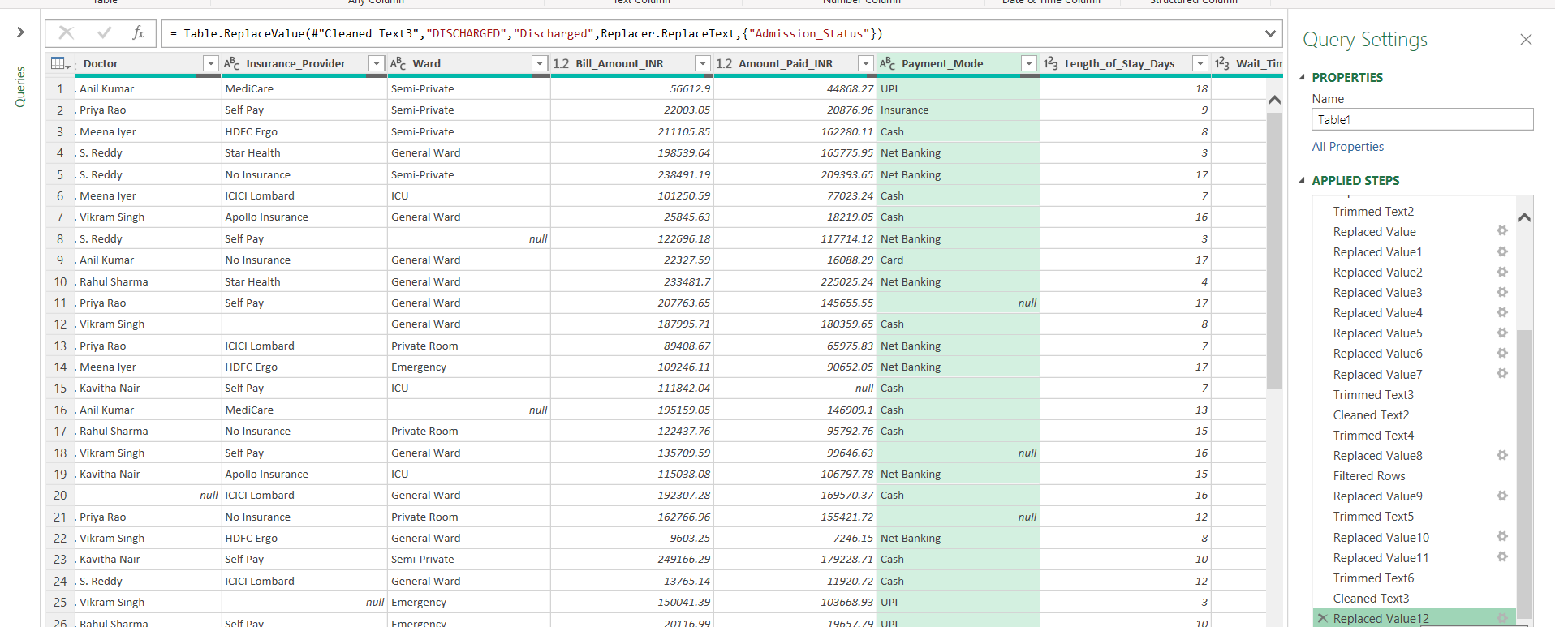

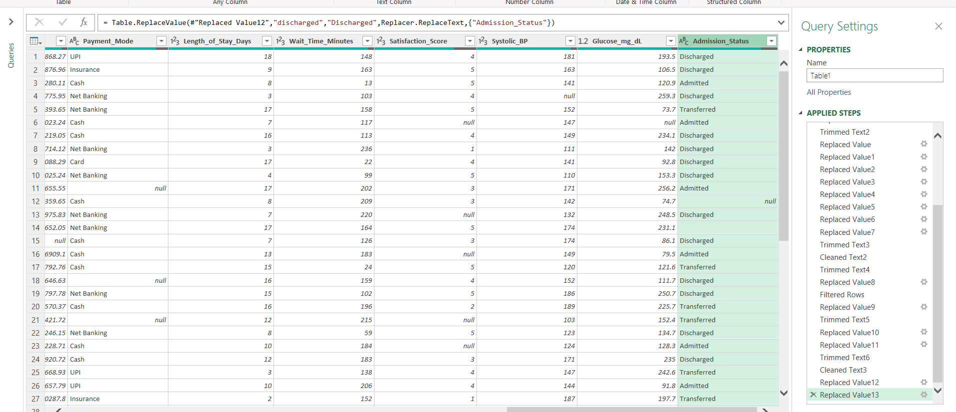

Replaced values in ward column
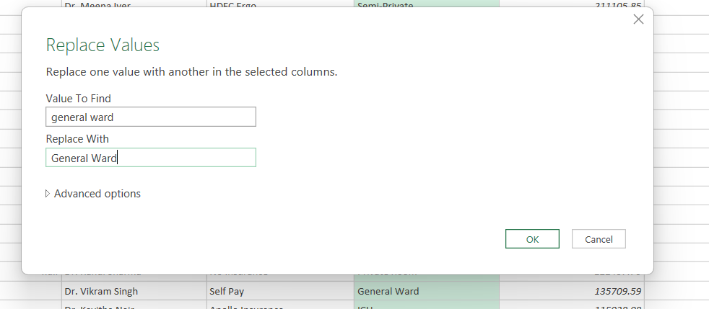

Convert all dates to a single date format.
By using locale and Date converted all the dates

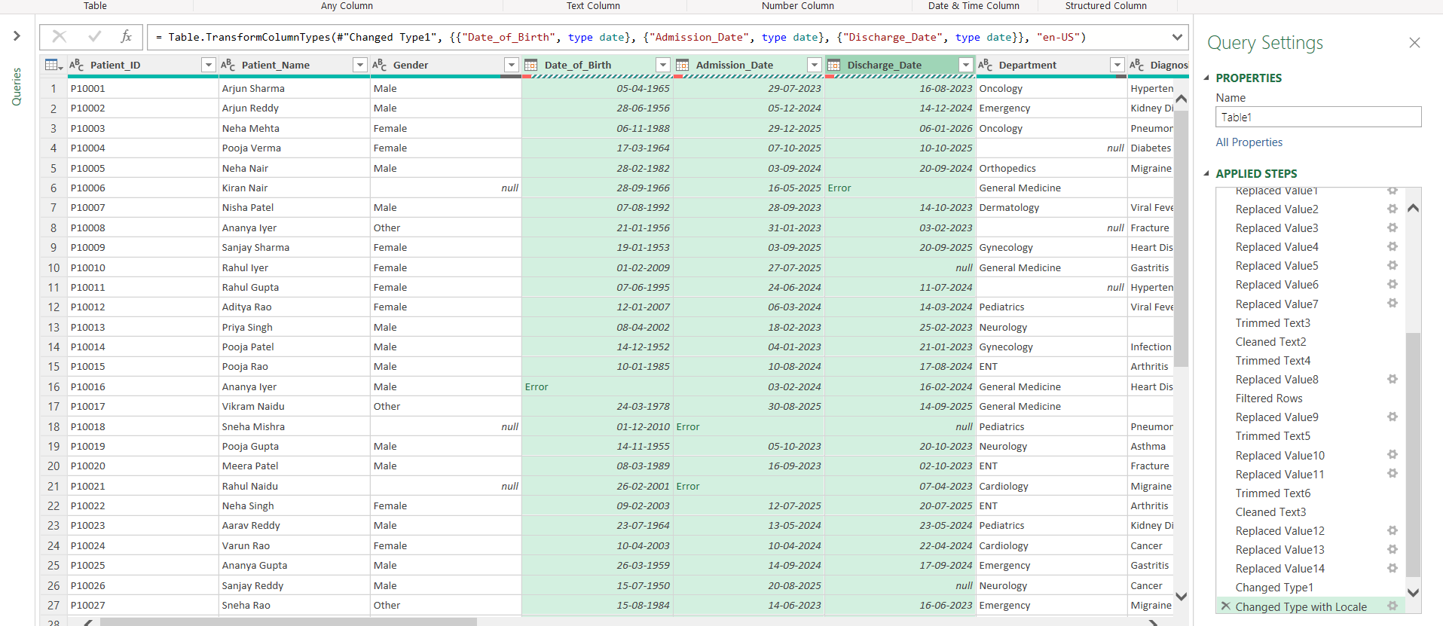

Convert Bill Amount and Amount Paid into numeric values.
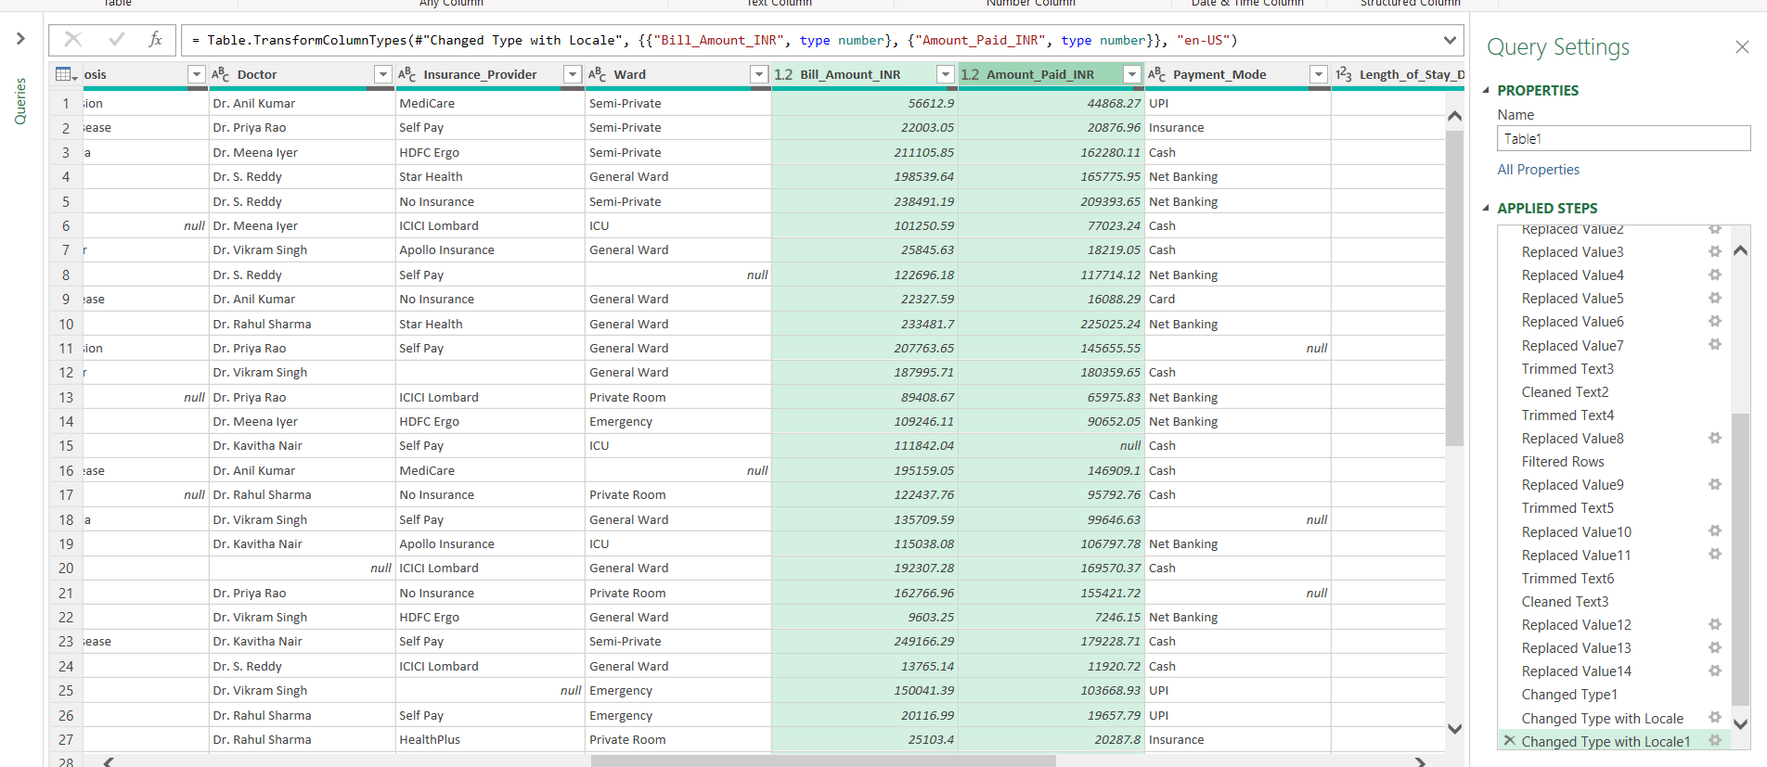

Handle null/missing values using documented business rules.
Replace with Unknow for Null Values in Date of Brith Column
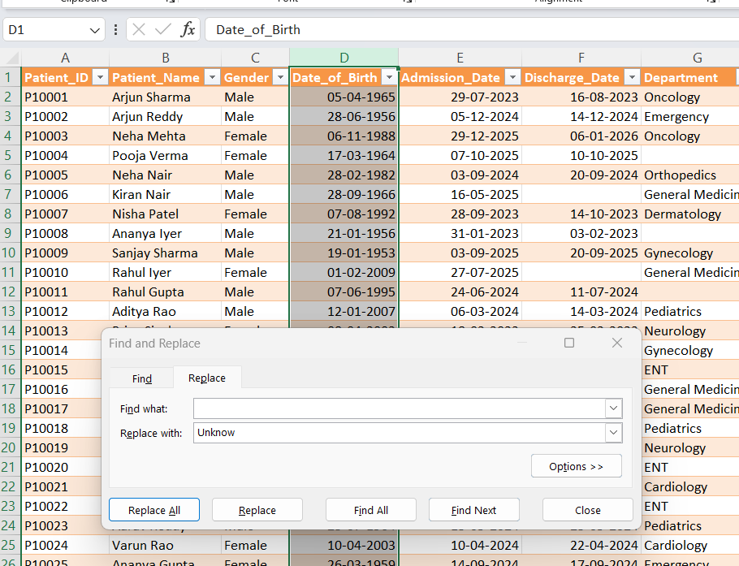
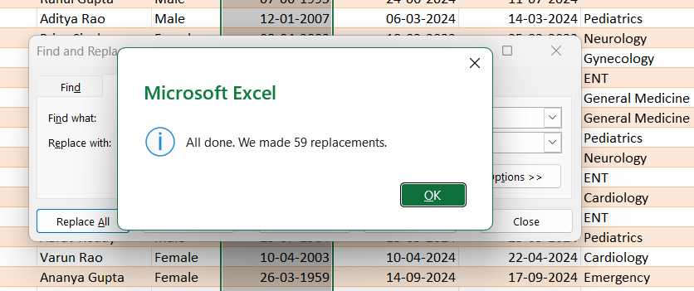

Do the same for Admission date, Discharge date column also
Relace with Unknown for null values
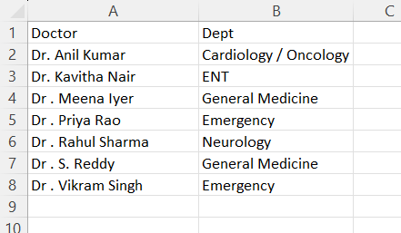
Based on this table Replace the Department column null values
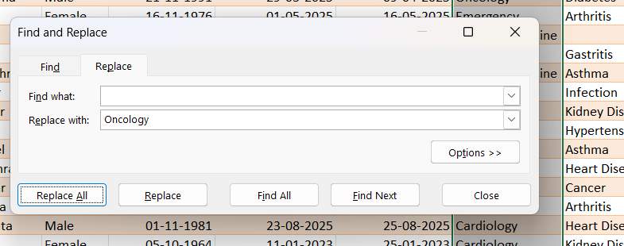
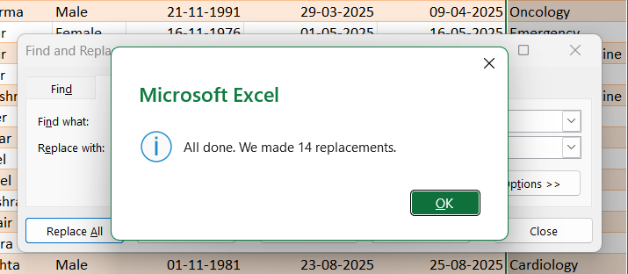

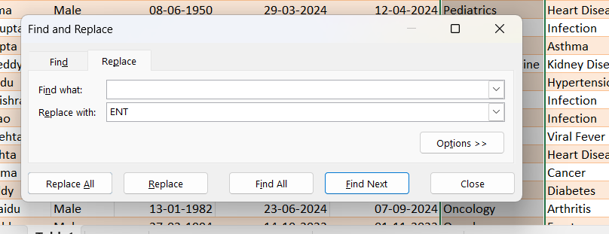
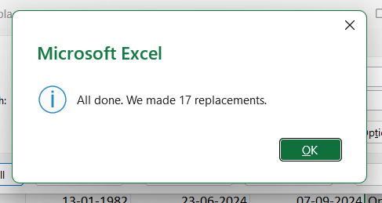
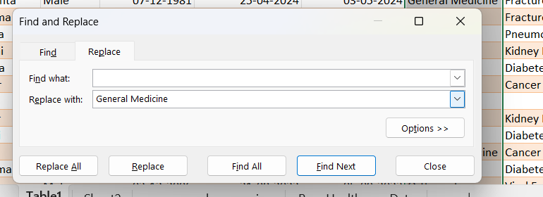
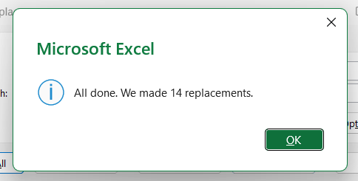
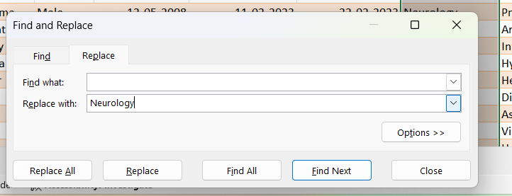
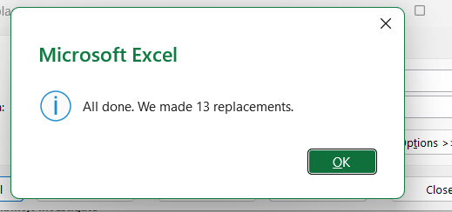

Diagnosis Column
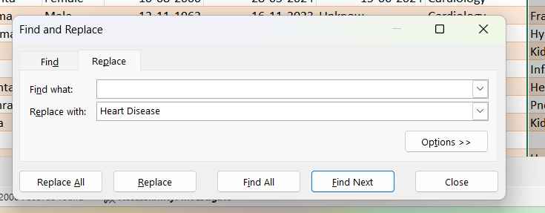
Based on department replaced the null values
Cardiology = Heart Disease
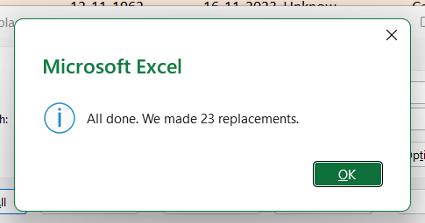
For Bill Amount Column
Find Median and replace with 123663.9 this Value
For Amount Paid column also done the same
Find median 98646.34 & Replace with this values
For all Numeric Columns find median and replace with that value
19-04-1980 Date of Birth
09-07-2024 Admission date Median Values – Did not Used
22-07-2024 Discharge date

DAX Formulas – Calculated New Measures
- Total Billed = CALCULATE(SUM(Healthcare[Bill_Amount_INR]))
- Total Collected = SUM(Healthcare[Amount_Paid_INR])
- Total Admissions = CALCULATE( COUNTROWS(Healthcare))
- Top Diagnosis Billing = MAXX(TOPN(1,SUMMARIZE(Healthcare,Healthcare[Diagnosis],"Bill",[Total Billed]),[Bill]),[Bill])
- Total Rows = COUNTROWS(Healthcare)
- Unknown Age Count = COUNTROWS(FILTER(Healthcare, Healthcare[Age_Group]="Unknown"))
- Unknown Stay Count = COUNTROWS(FILTER(Healthcare, Healthcare[Stay_Days]="Unknown"))
- Data Quality % = DIVIDE([Total Rows] - [Unknown Age Count] - [Unknown Stay Count], [Total Rows], 0)
- Avg Waiting (Mins) = AVERAGEX(FILTER(Healthcare,NOTISBLANK(Healthcare[Wait_Time_Minutes])),Healthcare[Wait_Time_Minutes])
- Avg Satisfaction = AVERAGE(Healthcare[Satisfaction_Score])
- Admissions by Dept = CALCULATE([Total Admissions],ALLEXCEPT(Healthcare,Healthcare[Department]))
- % Female = DIVIDE([Female Count],[Total Admissions],0)
- % Male = DIVIDE([Male Count],[Total Admissions],0)
- % of Total Admissions = DIVIDE([Admissions by Diagnosis], [Total Admissions], 0)
- % of Total Billing = DIVIDE([Billed by Diagnosis], [Total Billed], 0)

DATA MODEL
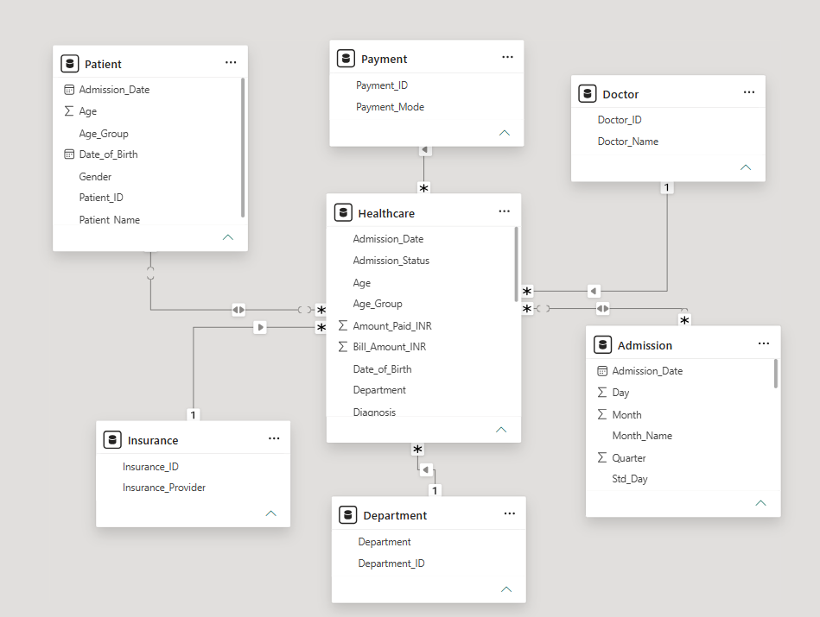
DASHBOARD

